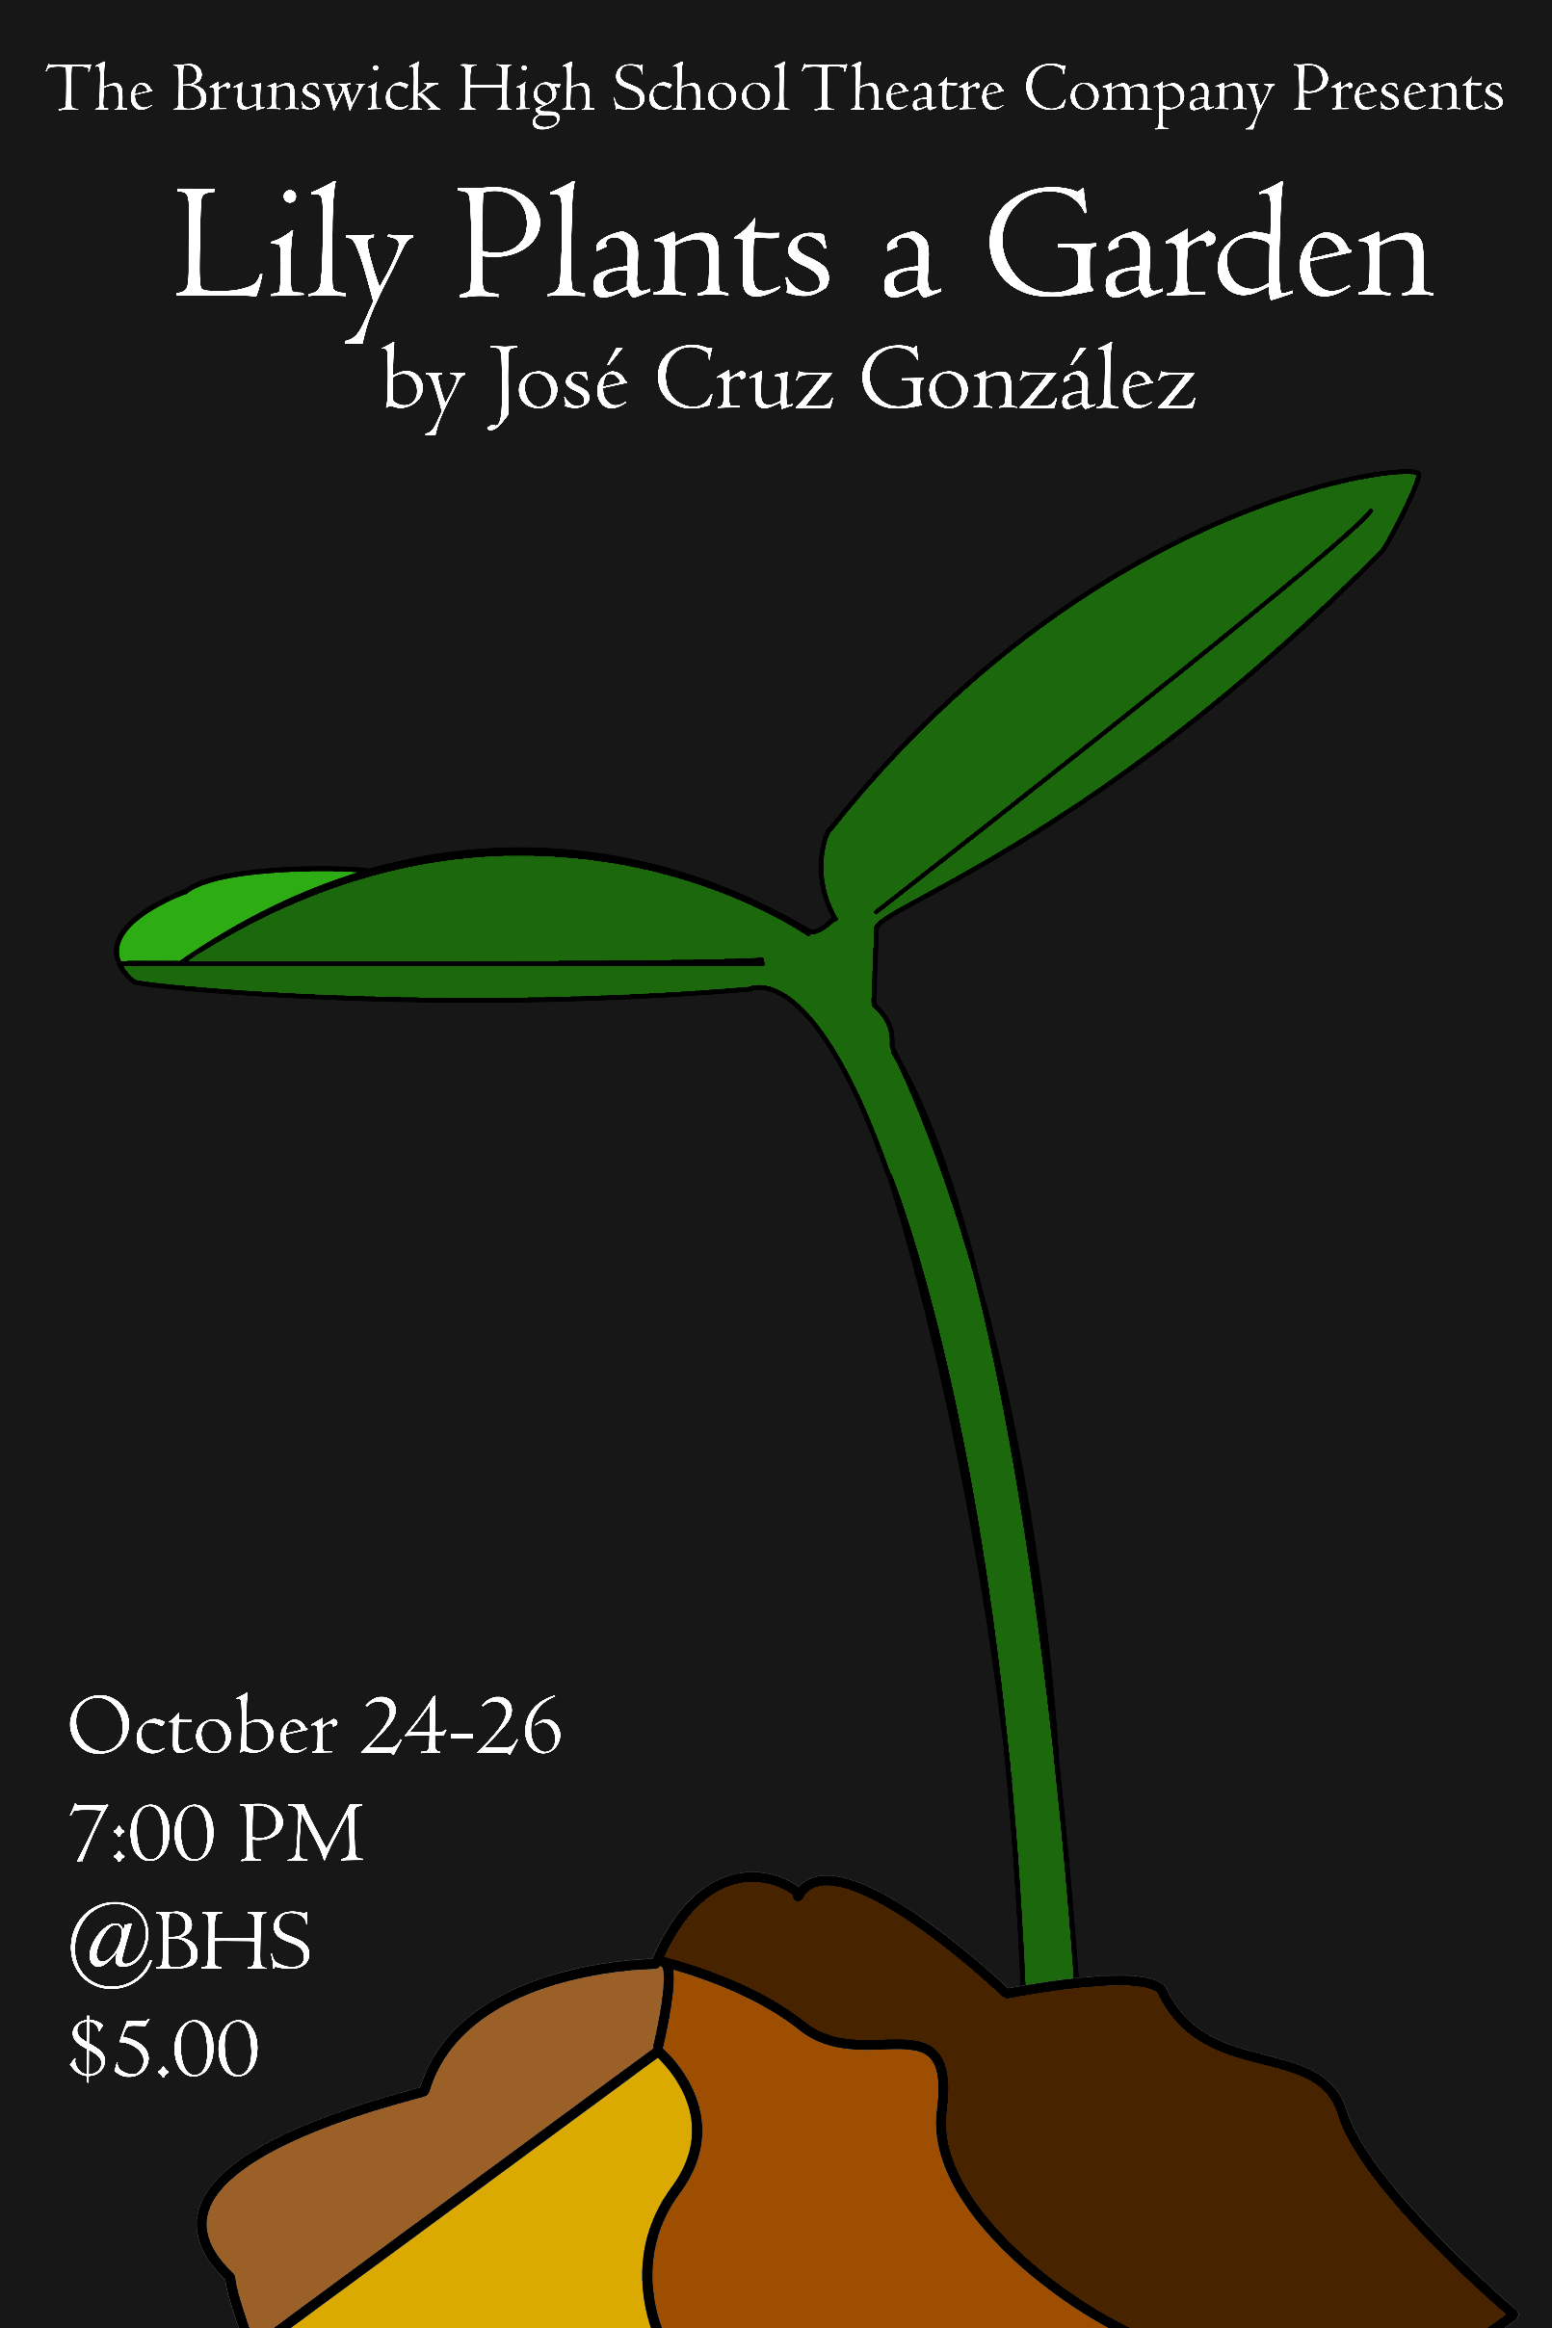

Cast
Nicholas Hodge | Miss Beatrice & Guards
Peyton Sanders | Papa Wuluman & Shadow
Angelina McGee | Mama Wuluman
Mia Taylor | Lily
Dakota Graf | Young Girl
Ensemble
Saleem Floy
Morgyhn Yockers
Joshua Anderson
Heather Dean

Tech
Kaytelin Goodbread | Stage Manager
Grace Schott | Assistant Stage Manager
Hannah Kate Chadwell | Crew
Guisella Garcia | Crew
Samantha Stephenson | Crew
Kaylin Kretzschmar | Crew

Creative Team
Lucy Lynn Bryson | Director
Peyton Sanders | Dramaturg
Jessica Gibbs-Zettler | Movement Director
Christopher S. Dills | Set Designer
Samuel Douglas | Sound Designer
Nicholas Hodge | Graphic Designer

Special Thanks
Brad Butler
Luck Flanders | Liz Sanders
Joan Nichols | Terri Schott
Austin Hodge | Laurie Frank
Desiah Brown
John Birge & The BHS Marching Pirates
Dr. Spence & The Faculty of BHS
All the Drama Mamas & Papas who have helped behind the scenes, brought food, worked Box Office, helped run lines, drive to and from rehearsals…and on and on and on.

Following our public performances of “Lily Plants a Garden,” BHS will compete in our GHSA Region Competition on Saturday, October 28th at Glynn Academy. We will be competing against GA’s Bonnie and Clyde, Richmond Hill’s The Final Rose, and Effingham’s The Great Nursing Home Escape. We would love to see you in the audience sporting your Blue & Gold at our 10:15am performance this Saturday!
In preparation to Saturday’s competition, tonight’s performance will simulate the Region competition. At the beginning of the show, the One-Act team will be asked if they are ready and will be told when their time begins. From that moment, the team has 55 minutes to set up, perform the play, and clear the stage.
Also, please refrain from using cameras, phones, or any electronic devices during the performances. It is distracting and dangerous for the actors.
Thank you for coming and enjoy the show!

Produced by special arrangement with
THE DRAMATIC PUBLISHING COMPANY of Woodstock, Illinois

